Curriculum Vitae

Dr. Reda Bardy Abdel-Rassoul, MD.
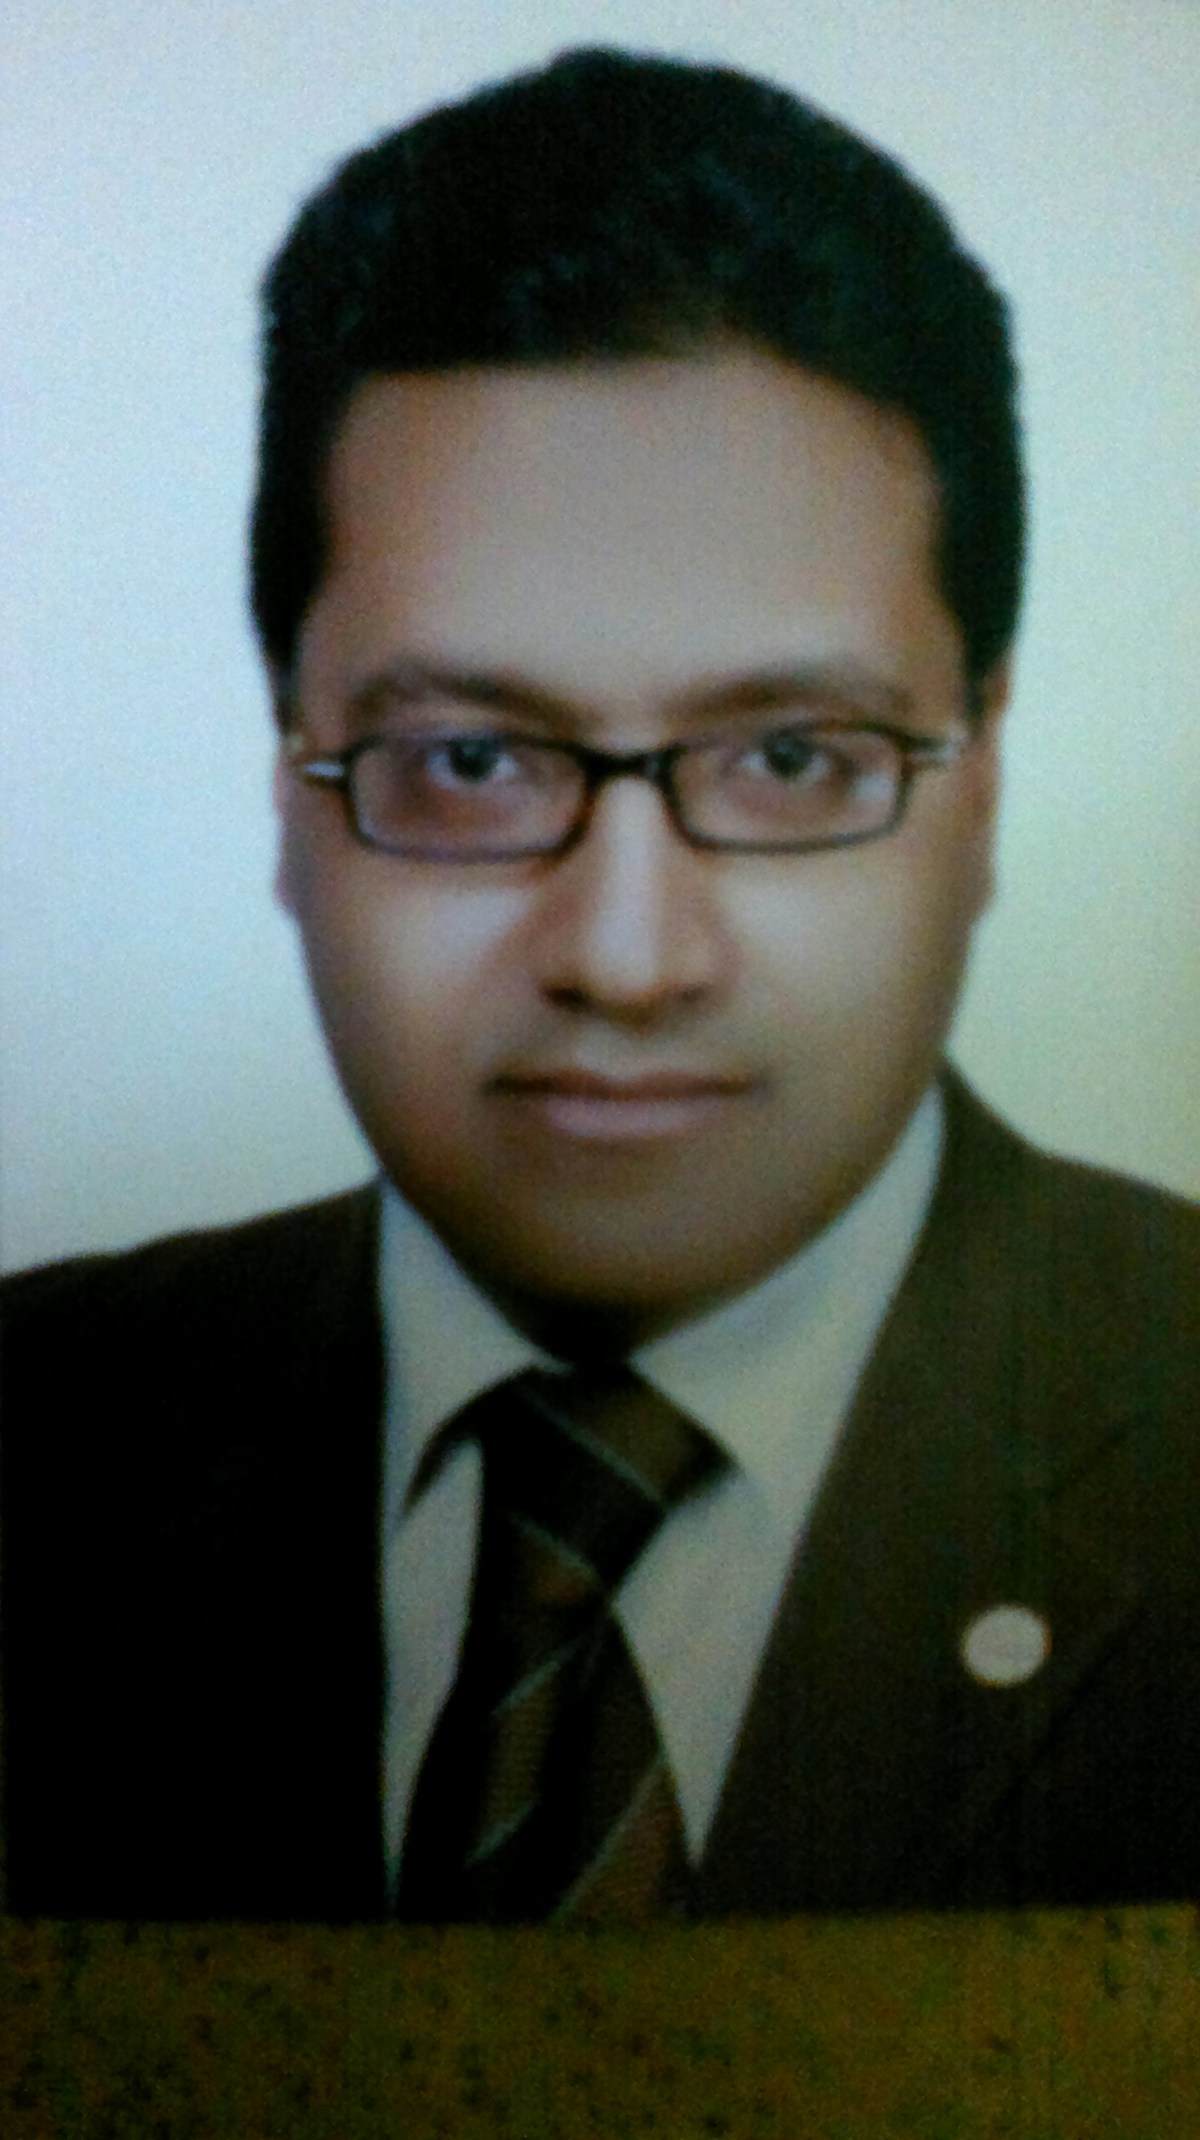

Personal data:
First name : Reda
Middle name : Badry
Last name : Abdel-Rassoul
Title : Assistant Professor of neurology, Assiut Univ.Hospital
Date of birth : January, 27th, 1976
Place of birth : Aswan, Egypt
Nationality : Egyptian
Affiliation : Assiut University, Faculty of Medicine, Assiut University Hospital, Neurology and Psychiatry Department
Home address : Al Azhar Univ. Street Borg Qebaa, Floor No. 10 Assiut, Egypt
Speciality : Neurology
Subspeciality : Neurophysiology and Epileptology
Phone : 0882141140 (home)
0100-833-6450 (mobile)
Fax : 020882333327
: 020882332278
Email : redaalbadry02@gmail.com
Mail Address : Department of Neurology and Psychiatry, Faculty of Medicine, Assiut University Hospital, Assiut, Egypt 71526

QUALIFICATIONS AND DEGREES:
- Bachelors of Medicine (MBBCH), Faculty of Medicine, Assiut University, 1999.
- Master Degree (MSC) in Neurology and Psychiatry, Assiut University, 2004.
- Enrolment in Human Brain Research Centre, Kyoto University, Japan 2006 to 2008.
- Doctorate degree in Neurology, Assiut University, 2009.

POSTS HELD:

From | To | Affiliation | Position
1/3/2000 | 28/2/2001 | Assiut University  Hospital | House Officer
2/3/2001 | 6/4/2004 | Assiut University Hospitals | Resident
26/5/2004 | 6/6/2006 | Assiut University Hospitals | Assistant Lecturer of Neurology
10/6/2006 | 9/6/2008 | Human Brain Research Centre, Kyoto University, Japan | PhD student
24/9/2009 | Till now | Assiut University Hospitals | Lecturer of Neurology

CLINICAL EXPERIENCE:
- Assiut University Hospital is the biggest hospital in Upper Egypt and the third biggest one in the whole country. It is 2000 bedded hospital. The department of Neurology and Psychiatry consists of 125 beds including Neurology Unit (50 beds), ICU Neurology Unit (10 beds), Neurophysiology Unit containing (conventional and digital EEG, Video monitoring EEG unit, EMG, Evoked potential and Transcranial magnetic stimulation or TMS) and Psychometric testing unit., Psychiatry Unit (77 beds).
- Human Brain Research Centre is one of high technology centeres all ovrer the world. It belongs to High graduate school of Medicine, Kyoto University, Japan. It is concerned with studying higher cortical functions.

- During my posts in this department, I have worked as a house officer (2 months), resident (3 years: 1 year in the Neurology department, 1 year in the Psychiatry department, 6 months in the Stroke unit, 3 months in the Emergency Units of the Internal Medicine, Neurology and Psychiatry ones and 3 month in the Neurophysiology Unit).

- During my studying in Japan, I was involved in nearly all clinical activities of Neurology department in Kyoto University. I worked in collaboration with a lot of researchers under supervision of head professors in the field of Neurology, Neurophysiology, Basic Neuroscience and Epileptology. Finally I published some of my researches during my stay in Japan.
Publications:
1- Steroid/Antiviral for the treatment of Bell's palsy: Double blind randomized clinical trial.
Restor Neurol Neurosci. 2016 Nov 22;34(6):897-905.
2- Spectrum of epilepsy - prevalence, impact, and treatment gap: an epidemiological study from Al-Quseir, Egypt. Neuropsychiatr Dis Treat. 2016 May 12;12:1111-8. doi: 10.2147/NDT.S87765. eCollection 2016.
3- Prevalence of multiple sclerosis in Al Quseir city, Red Sea Governorate, Egypt.
Neuropsychiatr Dis Treat. 2016 Jan 13;12:155-8. doi: 10.2147/NDT.S87348. eCollection 2016.
4- Epidemiology and clinical presentation of stroke in Upper Egypt (desert area).
Neuropsychiatr Dis Treat. 2015 Aug 21;11:2177-83. doi: 10.2147/NDT.S87381. eCollection 2015.

5- Commentary.
J Neurosci Rural Pract. 2014 Nov;5(Suppl 1):S77. No abstract available.
6- Different types of headache in patients with systemic lupus erythematosus.
Int J Neurosci. 2015 May;125(5):357-60. doi: 10.3109/00207454.2014.951041. Epub 2014 Sep 3.
7- Cerebral palsy in Al-Quseir City, Egypt: prevalence, subtypes, and risk factors.
Neuropsychiatr Dis Treat. 2014 Jul 8;10:1267-72. doi: 10.2147/NDT.S59599. eCollection 2014.
8- Epileptic and cognitive changes in children with cerebral palsy: an Egyptian study.
Neuropsychiatr Dis Treat. 2014 May 29;10:971-5. doi: 10.2147/NDT.S59600. eCollection 2014.
9- Changes in motor cortical excitability in patients with Sydenham's chorea.
Mov Disord. 2015 Feb;30(2):259-62. doi: 10.1002/mds.25928. Epub 2014 Jun 7.
10- Selenium and antioxidant levels decreased in blood of children with breath-holding spells. J Child Neurol. 2014 Oct;29(10):1339-43. doi: 10.1177/0883073813515076. Epub 2014 Jan 10.
11- Prevalence of Parkinson's disease and other types of Parkinsonism in Al Kharga district, Egypt. Neuropsychiatr Dis Treat. 2013;9:1821-6. doi: 10.2147/NDT.S48318. Epub 2013 Nov 26.
12- Prevalence of dementia in Al-Quseir city, Red Sea Governorate, Egypt.
Clin Interv Aging. 2014;9:9-14. doi: 10.2147/CIA.S48325. Epub 2013 Dec 6. Erratum in: Clin Interv Aging. 2014;9:129.

13- Turner syndrome: review of clinical, neuropsychiatric, and EEG status: an experience of tertiary center. Acta Neurol Belg. 2014 Mar;114(1):1-9. doi: 10.1007/s13760-013-0264-9. Epub 2013 Dec 12. Review.
14- Clinical and neuropsychiatric status in children with Williams-Beuren Syndrome in Upper Egypt. Asian J Psychiatr. 2013 Dec;6(6):560-5. doi: 10.1016/j.ajp.2013.08.069. Epub 2013 Aug 27.
15- Epidemiology of non-fatal cerebrovascular stroke and transient ischemic attacks in Al Quseir, Egypt. Clin Interv Aging. 2013;8:1547-51. doi: 10.2147/CIA.S48785. Epub 2013 Nov 21.
16- Epidemiology of nonfatal stroke and transient ischemic attack in Al-Kharga District, New Valley, Egypt. Neuropsychiatr Dis Treat. 2013;9:1785-90. doi: 10.2147/NDT.S48322. Epub 2013 Nov 18.
17- Prevalence of neurological disorders in Al Quseir, Egypt: methodological aspects.
Neuropsychiatr Dis Treat. 2013;9:1295-300. doi: 10.2147/NDT.S42392. Epub 2013 Sep 9.
18- Trace element, oxidant, and antioxidant enzyme values in blood of children with refractory epilepsy. Int J Neurosci. 2014 Mar;124(3):181-6. doi: 10.3109/00207454.2013.831851. Epub 2013 Sep 3.
19- Door-to-door survey of major neurological disorders (project) in Al Quseir City, Red Sea Governorate, Egypt. Neuropsychiatr Dis Treat. 2013;9:767-71. doi: 10.2147/NDT.S36956. Epub 2013 May 27.
20- Prevalence of spinal cord disorders in Al-Quseir City, Red Sea Governorate, Egypt.
Neuroepidemiology. 2013;41(1):42-7. doi: 10.1159/000348320. Epub 2013 May 25.

21- Prevalence of trigeminal neuralgia in Al-Quseir city (Red sea Governorate), Egypt.
Clin Neurol Neurosurg. 2013 Sep;115(9):1792-4. doi: 10.1016/j.clineuro.2013.04.014. Epub 2013 May 18.
22- Epidemiology of uncontrolled epilepsy in the Al-Kharga District, New Valley, Egypt.
Seizure. 2013 Oct;22(8):611-6. doi: 10.1016/j.seizure.2013.04.010. Epub 2013 May 14.
23- Latency to the first epileptiform activity in the EEG of epileptic patients.
Int J Neurosci. 2013 Sep;123(9):646-9. doi: 10.3109/00207454.2013.785543. Epub 2013 Apr 15.
24- Value of latency difference of the second lumbrical-interossei as a predictor of carpal tunnel syndrome in uremic patients. J Clin Neurophysiol. 2013 Feb;30(1):92-4. doi: 10.1097/WNP.0b013e31827ec5e7.
25- Epidemiology of epilepsy in New Valley Governorate, Al Kharga District, Egypt.
Epilepsy Res. 2013 Mar;104(1-2):167-74. doi: 10.1016/j.eplepsyres.2012.08.010. Epub 2012 Sep 13.
26- Role of short-term out patient video electroencephalography in diagnosis of paroxysmal disorders. Epilepsy Res. 2010 Feb;88(2-3):179-82. doi: 10.1016/j.eplepsyres.2009.11.001. Epub 2009 Dec 3.
27- Suppression of human cortico-motoneuronal excitability during the Stop-signal task.
Clin Neurophysiol. 2009 Sep;120(9):1717-23. doi: 10.1016/j.clinph.2009.06.027. Epub 2009 Aug 15.

Conferences Attended:
- All American Academy annual meetings since 2012 till now.
- All American Epilepsy Association annual meetings since 2012 till now.
- International Neuroscience congress, Yokohama, Japan, March, 2008.
- International congress of Movement disorders , Kyoto, May, 2007
- Workshop of basic skills of Epilepsy diagnosis and treatment, Kyoto, February, 2008.
- First International Neuroepidemiology congress, Egypt, Luxor, March, 2009.
- Second International Neuroepidemiology congress, Egypt, Hurgada, March, 2012.
- Nearly All CNC (Cairo Neurology Conferences) held between 2002 till 2012, Egypt.
- The Conference of the Egyptian Society of Neurology, Psychiatry, and Neurosurgery (ESNPN), Assiut Faculty of Medicine, October 4th –6th 2000.
- The 20th Annual Scientific Conference of Faculty of Medicine, Assiut University, (Modern Trends in Medicine), 24th –27th December, 2001.
- The 4th Neuromediterranean Conference, Assiut- Luxur, March 27th –30th 2002.
- Workshop of Basic Epidemiological Studies 26th march 2002. In the 4th NMC 27th –30th march 2002.
- The 10th Annual Conference of the Department of Neurology and Psychiatry-Assiut University in collaboration with Egyptian Society of Neurology, Psychiatry, and Neurosurgery (ESNPN), Assiut 22 – 23rd October 2003.
- The 1st Annual Scientific Conference of the Department of Neurological Surgery-Assiut University in collaboration with Egyptian Society of Neurological surgeons. Assiut, December 4th – 5th 2003.
- The 6th Arab Conference for Prevention of Substance Abuse, 24th -25th November2004
- The 11th Annual Conference of the Department of Neurology and Psychiatry-Assiut University in collaboration with Egyptian Society of Neurology, Psychiatry, and Neurosurgery (ESNPN) March 31st - April 1st 2005.
Additional qualifications:
  - Certificate of international TOEFL at August 2005.
  - ICDL at March 2006.
  - Preliminary and semi intensive courses of Japanese language, July, 2006.
  - Advanced course of SPSS program of medical statistics, Faculty of Medicine, Assiut University.
  - Training course about Botulinum toxin injection at faculty of medicine, Cairo University.
  - Advanced course about Cardiopulmonary Ressuscitation, Faculty of medicine, Assiut University

THESIS EXPERIENCE:
Master Thesis project: “Neuropsychological assessment of patients with vascular and Alzheimer's dementia"
M.D. Thesis Title: “Role of video monitoring EEG in differentiating epileptic and non epileptic events“.
Supervision of many master and doctorate thesis in Department of Neurology and Psychiatry, Assiut Univ.
MEMBERSHIP:
- Japanese society of Neurophysiology.
- Egyptian Society of Neurology, Psychiatry and Neurosurgery.
- American Academy of Neurology.
- American Epilepsy Society.

